HD 11964

HD 11964 is a 1.12 M☉, G5 star1. Based on 119 RV HIRES measurements obtained between 1996 and 2008, a study performed in 2009 (hereafter W09)2 reported a Hot Jupiter (HD 11964b) with a period of 37.910 ± 0.041 days, a minimum mass of 0.0788 ± 0.0097 MJup and an eccentricity of 0.3 ± 0.17 as well as a GP (HD 11964c) with a period of 1945 ± 26 days, a minimum mass 0.622 ± 0.056 MJup and an eccentricity of 0.041 ± 0.047.The CH survey reported properties close to those reported in the W09 study for both planets.

In the present study, in addition to the W09’s dataset, 194 RV HARPS measurements obtained between 2003 and 2017 were considered. DPASS and MCMC (1000 walkers, 300000 iterations) were used to fit the data. To converge more easily, the priors on the semi-major axis and the minimum mass of HD 11964b were close to the values found by the W09 study. The properties of planets b and c are close to those reported in the CH survey.

The fits are shown in Fig 1, and the corner plot in Fig 2, and the results summarized in Table 1.

Conclusion: The properties found in the CH survey for both planets are confirmed.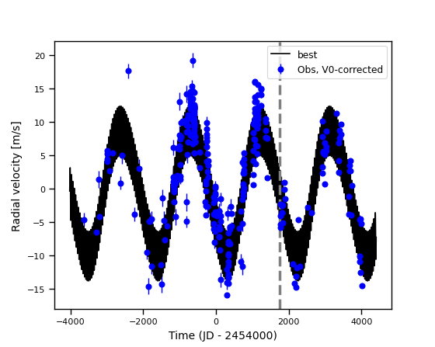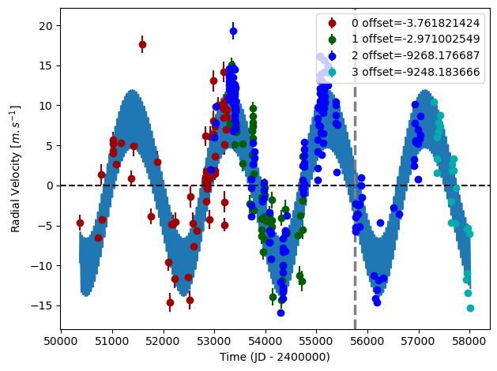

Figure 1: Left: fit of the HD 11964 RV with DPASS. Red (resp. green, blue, and cyan) points correspond to the Hir94 (resp. Hir04, H03 and H15) data. The blue curve shows the best fit. Right: fit of the HD 11964 RV using MCMC. The black curve shows the best fit. The gray dotted line indicates the end of the CH survey.

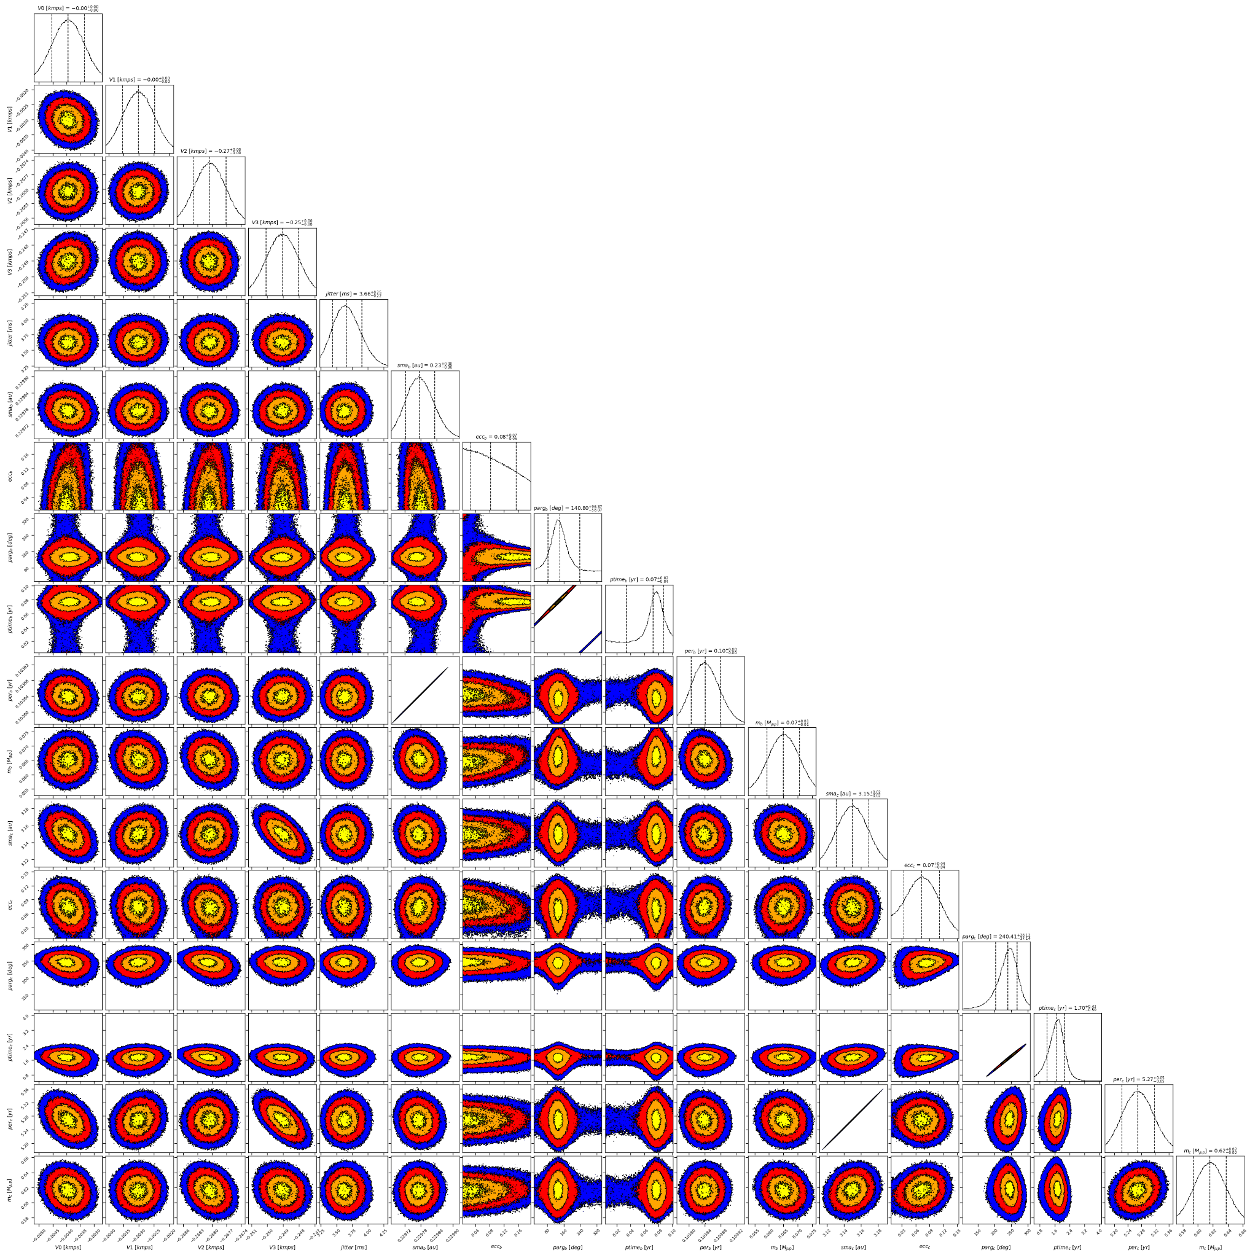

Figure 2: Corner plot of posteriors for the two-planets model MCMC fit of HD 11964 RV data.

| Parameter | Priors | | Posteriors | | CH survey |
| --- | --- | --- | --- | --- | --- |
|  | DPASS | MCMC | DPASS | MCMC |  |
| *a* (au) | b: [0,0.4]  c: [0,80] | b: [0.22,0.24]  c: [2,10] | b = 0.23  c = 3.1 | b = 0.229 ± 0.001  c = | b = 0.23  c = 3.2 |
| Msin(i) (MJup) | b: [0,1]  c: [0,100] | b: [0.06,0.07]  c: [0.1,5] | b = 0.064  c = 0.61 | b = 0.065 ± 0.006  c = | b = 0.053  c = 0.55 |
| Eccentricity | b: [0,0.4]  c: [0,0.95] | b: [0.05,0.15]  c: [0,0.9] | b = 0.12  c = 0.07 | b < 0.15  c = | b = 0.21  c = 0.07 |
| Instrumental offset (km/s) | [-60,60] | Hir94: [-1,1]  Hir04: [-1,1]  H03: [-10,-8]  H15: [-10,-8] | Hir94: -0.004  Hir04: -0.003  H03: -9.268  H15: -9.248 | Hir94: -  Hir04: -  H03: -  H15: - |  |
| Stellar jitter (m/s) | [0,40] | [0,20] | 3.5 |  |  |
| Argument of periastron (°) | b: [0,360]  c: [0,360] | b: [0,360]  c: [0,360] | b = 195  c = 217 | b = 81 – 248  c = 183 – 267 |  |
| Phase | b: [0,1]  c: [0,1] | b: [0,1]  c: [0,1] | b = 0.84  c = 0.49 | b = 0.29 – 0.84  c = |  |

Table 1: HD 11964. Summary of priors and posteriors with DPASS and MCMC, compared to the properties reported by CH Survey.

References

1. Ghezzi, L. et al. Metallicities of Planet-hosting Stars: A Sample of Giants and Subgiants. *Astrophys. J.* 725, 721-733 (2010).
2. Wright, J. et al. Ten New and Updated Multiplanet Systems and a Survey of Exoplanetary Systems. *Astrophys. J.* 693, 1084-1099 (2009).